NEWS RELEASE – Area Agency on Aging District 7, Inc.
Release Date: Tuesday, August 3, 2010
Contact: Jenni Dovyak, Communications Manager
F-32 PO Box 500
Rio Grande, OH 45674
Phone: 740.245.5306/Toll-Free 1.800.582.7277
E-Mail: jdovyak@aaa7.org



Thanks Given and Awards Presented at
AAA7 Annual Appreciation Brunch

Giving thanks. That was common place at this year’s Area Agency on Aging District 7’s Appreciation Brunch, which was recently celebrated at the Southern Ohio Medical Center Friends Center in Portsmouth.

Throughout the special event, several individuals and groups throughout the Agency’s 10-county district were recognized for their service and dedication to not only the Agency as a whole, but more importantly, the communities and seniors served by the Agency. The Area Agency on Aging District 7, Inc. serves the following counties: Adams, Brown, Gallia, Highland, Jackson, Lawrence, Pike, Ross, Scioto and Vinton.

Special awards that were presented at the event to individuals or groups included:

William A. Jenkins Award (Outstanding Contributor to Our Southern Ohio Aging Network)
This year’s Area Agency on Aging District 7, Inc. “William A. Jenkins Award” was presented to Alvin Norris, Executive Director of the Adams-Brown Economic Opportunities, Inc. (ABEOI), a community action organization serving Adams and Brown counties. The AAA7 presents the award annually to an outstanding contributor to the southern Ohio aging network.

Norris is a 1974 graduate of Miami University in Oxford, Ohio, where he earned a bachelor’s degree in sociology, and a 1994 graduate of the University of Dayton, where he earned a master’s degree in education.

Norris began his employment at the ABEOI in September 1974 as a social worker in the Child Development Program. In May of the following year, he was promoted to Youth Program Director before assuming the role of Manpower Director in October 1976. In 1980, Norris became the Executive Director of ABEOI, the position he continues to hold today.

Norris’ leadership with low-income senior housing and the needs of the elderly, including a senior nutrition program and in-home services, have certainly served Adams and Brown County seniors well. The AAA7 presented this special award to Norris for his over 35 years of dedicated service to rural southern Ohio residents in the greatest social and economic need, and for his ongoing commitment to better the lives of those living in Adams and Brown Counties.

The award is named in memory of William A. Jenkins, a native of Gallia County, who helped build the aging network in southern Ohio through the Area Agency on Aging District 7, Inc.

Legislator of the Year Award
This year’s Area Agency on Aging District 7, Inc. “Legislator of the Year Award” was presented to State Senator John Carey.

Senator Carey was instrumental in helping with legislation, that was signed into law on May 27, 2010, surrounding Home First, a program which broadens access to home and community-based services for Ohioans when waiting lists exist, giving many older Ohioans, their families and caregivers the choice they desire and deserve. This “Home First” legislation extends the program to older adults leaving hospitals or in abusive and/or self-neglect situations, as well as those who have depleted their assets in assisted living facilities, or whose physicians have signed that they are at risk of nursing facility placement within 30 days.

Pam Matura, Executive Director of the AAA7, recognized Senator Carey for his willingness to be a true champion of such an important cause, and his role as one of Ohio’s best champions for older adults. Matura also made mention of the “close to home” feel of the legislation as the initial idea came forth from a conversation she had with Senator Carey regarding the issues Home First now addresses. Matura applauded Senator Carey for his advocacy, leadership, and vision that helped transform the idea to a state law that can now benefit a great number of older Ohioans.

Trailblazer Award
This year’s Area Agency on Aging District 7, Inc. “Trailblazer Award” was presented to the AAA7 Regional Long-Term Care Ombudsman Program.

The Ombudsman Program was recognized for its hard work and dedication with “Home Choice”, a program that was designed to assist individuals when moving from a nursing home to life back in a home or community-based setting. The Home Choice program, made possible by funds from the federal Centers for Medicare and Medicaid Services, will enable around 2,200 Ohio seniors and persons with disabilities to experience the smoothest transition possible between their nursing home stay and return to home.

The Regional Long-Term Care Ombudsman Program, under the leadership of Kaye Inoshita, RN, was recognized at the event for their tireless work and dedication to individuals who need personalized assistance with this special transition.

Partnership Award
This year’s Area Agency on Aging District 7, Inc. “Partnership Award” was presented to Melanie McPeak of Edgewood Manor in Wellston, and Russ Pruitt of Pleasant Hill Manor in Waverly.

Both McPeak and Pruitt were essential partners and supporters of the AAA7’s Regional Long-Term Care Ombudsman Program and the Home Choice program, as mentioned with the Trailblazer Award.

According to Kaye Inoshita, RN, Director of the AAA7’s Regional Long-Term Care Ombudsman Program, both McPeak and Pruitt are social workers who went beyond their normal responsibilities to help residents transition back into their communities. This included assistance with shopping for items needed on the return to home, assisting with arranging medical equipment and in-home services, as well as even organizing a “going-away” party for one resident before his return back home. Their assistance, dedication and partnership with the AAA7’s Regional Long-Term Care Ombudsman Program has made the Home Choice program one that is making a difference in the lives of others.

Intergenerational Service Award
This year’s Area Agency on Aging District 7, Inc. “Intergenerational Service Award” was presented to Brownie Troop #1926 from Minford in Scioto County.

Over the year, Brownie Troop #1926 has volunteered at a number of events to help seniors who are enrolled in the Agency’s Residential State Supplement and Assisted Living programs. The Troop delivered Easter baskets and Christmas stockings to 100 residents living in adult group homes in Lawrence County, and most recently sponsored an Ice Cream Social at Holzer Assisted Living in Jackson where one of the residents shared that although they enjoyed the ice cream very much, spending time with the girls was the real “treat”.

Troop Leader, Dawn Blankenship, reports that the community service projects have been the girls’ favorite. “The girls love showing others that they are cared about and through their volunteer work, are able to see firsthand that although they are young, they can still make a difference in someone else’s life,” she commented.

Special recognition was also given at the event to the following groups and individuals:

Regional Long-Term Care Ombudsman Volunteers
John Brewer, Rich Burton, Sharon Fagan, Joyce Harber, Jan Harper, Sherry Headley, Doug McCoard, Debby Mersiel, Margaret Miller, Lois Nause, Paul Plymale, Lavon Shields, Jerry Towler and Kim Wicker.

Art Show and Essay/Poetry Contest Volunteers
Rita Baker, Betty Bouts, Jane Bragg, Helen Brohard, Carolyn Coon, Phyllis Fulk, Joyce Haag, Virginia Horn, Jayne Horton, Carolee Lewis, Rosemary Matthews, Mary Maxson, Rushie McAllister, Annabelle Miller, Inez Miller, Bob Powell, Vickie Powell, Barbara Shelton, Lavon Shields, Irena Skaggs, Anna Summers, Phyllis Taylor, Phyllis Wade and Ruth Yates.

Outstanding Seniors (As Selected by Each County Senior Center)
Adams County – Isaac Burton Young; Gallia County – Charlotte Patrick; Highland County – Hugh and Sharon Fenner, Ray Fenner, Bud Fenner and Jeannette Fenner Knauff; Jackson County – Judith A. Bowling; Lawrence County – Bonnie Fitzpatrick and Lena Brown; Pike County – Violet Williams; and Ross County – Wilma Graves and Norma Bennett.

State Awardees (District Honorees from the Ohio Department of Aging)
Elder Caregiver of the Year Award – George Gray (Scioto County)
Senior Hall of Fame Inductee – Dr. Mel Simon (Gallia County)
Joined Hearts in Giving – Earl and Betty Miller (Scioto County)
Joined Hearts in Giving – Hugh and Barb Cahill (Brown County)

The Area Agency on Aging District 7 was pleased to host another successful Appreciation Brunch to extend their thankfulness and appreciation to all the individuals and groups who make its district so special.

Your local Area Agency on Aging District 7, Inc. provides services on a non-discriminatory basis in the following Ohio counties: Adams, Brown, Gallia, Highland, Jackson, Lawrence, Pike, Ross, Scioto and Vinton. These services are available to help older adults and those with disabilities live safely and independently in their own homes through services paid for by Medicare, Medicaid, Veterans Administration, other federal and state resources, as well as private pay.

Those interested in learning more can call toll-free at 1-800-582-7277 (TTY 1-888-270-1550). Here, individuals can speak directly with a nurse or social worker who will assist them with information surrounding the programs and services that are available to best serve their needs. Information is also available on www.aaa7.org.

###
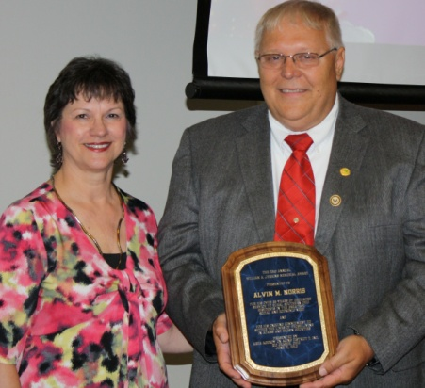
William A. Jenkins Award - Pictured is, left, Pamela K. Matura, Executive Director of the Area Agency on Aging District 7, Inc., who presents the Area Agency on Aging District 7’s William A. Jenkins Award to Alvin Norris.

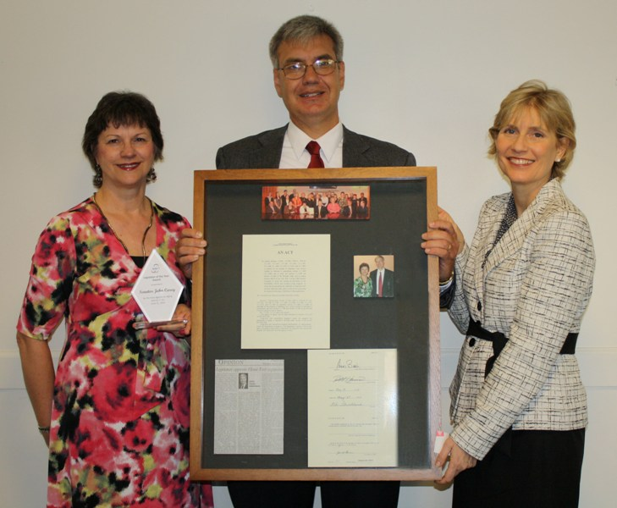

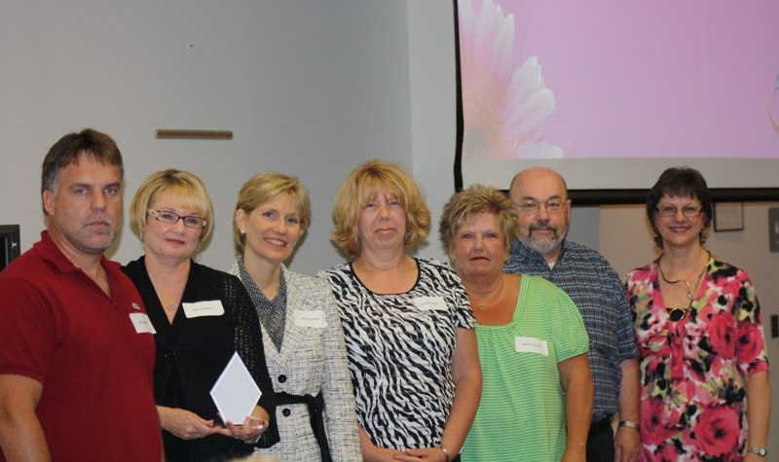

Legislator of the Year Award - Pictured is, left, Pamela K. Matura, Executive Director of the Area Agency on Aging District 7, Inc., and right, Larke Recchie, Executive Director of the Ohio Association of Area Agencies on Aging, who present the Area Agency on Aging District 7’s “Legislator of the Year Award” to Ohio State Senator John Carey.
Trailblazer Award - Pictured is, far right, Pamela K. Matura, Executive Director of the Area Agency on Aging District 7, Inc., and third from the left, Larke Recchie, Executive Director of the Ohio Association of Area Agencies on Aging, who present the Area Agency on Aging District 7’s “Trailblazer Award” to the Area Agency on Aging District 7 Regional Long-Term Care Ombudsman Program. Pictured, left to right, are Rex Sanders, Kaye Inoshita, Cindy Oakes, Debbie Collier and John Hogan.

[Type a quote from the document or the summary of an interesting point. You can position the text box anywhere in the document. Use the Text Box Tools tab to change the formatting of the pull quote text box.]
Partnership Award - Pictured is, left, Melanie McPeak of Edgewood Manor in Wellston, and far right, Russ Pruitt, of Pleasant Hill Manor in Waverly, who receive the Area Agency on Aging District 7’s “Partnership Award” from Larke Recchie, Executive Director of the Ohio Association of Area Agencies on Aging, and Kaye Inoshita, Director of the Area Agency on Aging District 7’s Regional Long-Term Care Ombudsman Program.

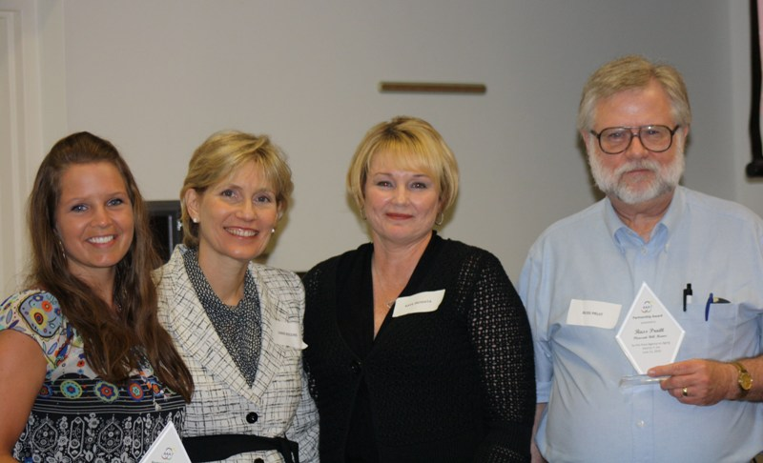
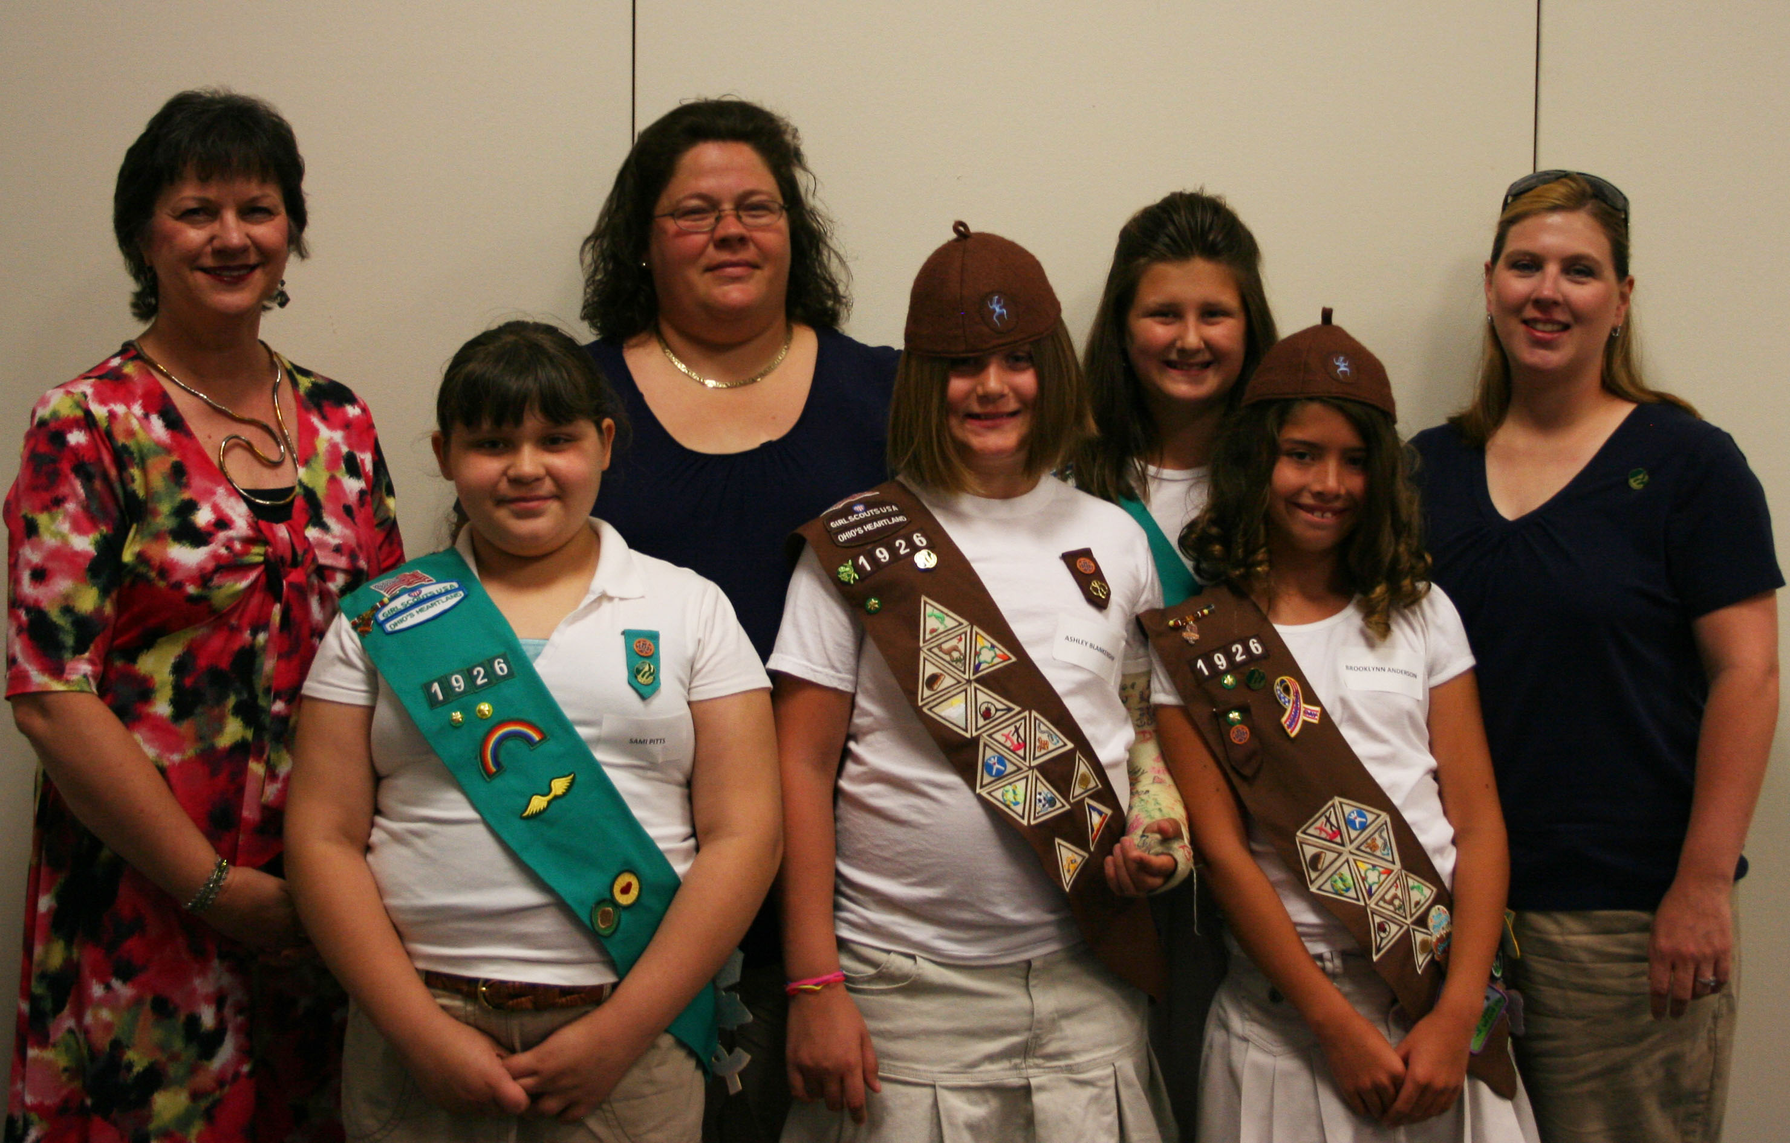
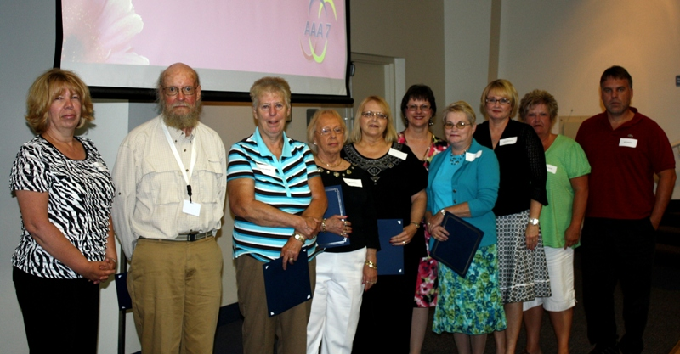
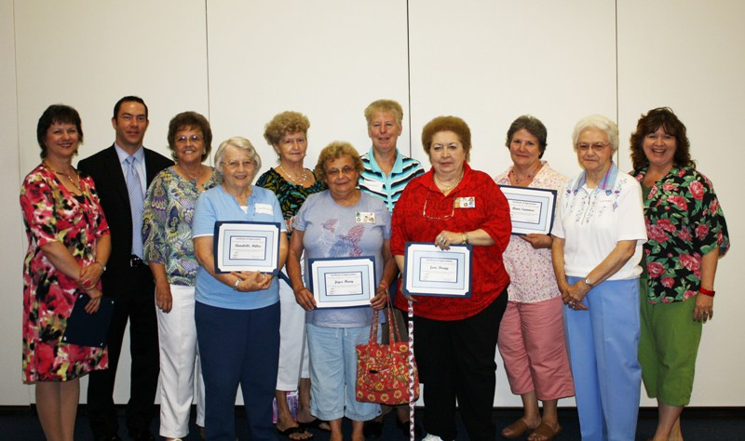
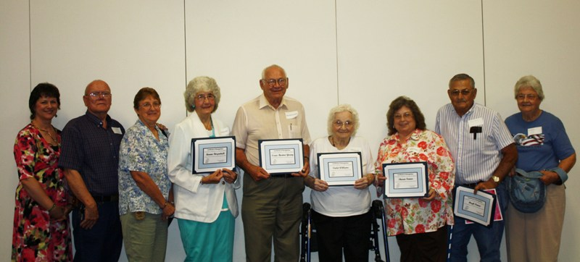

Intergenerational Service Award - Pictured is, left, Pamela K. Matura, Executive Director of the Area Agency on Aging District 7, Inc., who presents the Area Agency on Aging District 7’s “Intergenerational Service Award” to Brownie Troop #1926 from Minford in Scioto County. Pictured front row, left to right, Samantha Pitts, Ashley Blankenship and Brooklynn Anderson. Back row, left to right, Pam Matura, Parent Volunteer Jody Pitts, Kaitlyn Blankenship and Troop Leader Dawn Blankenship. Not pictured is Hope Caudill, Julia Lundy and Taylor Simpson

Ombudsman Volunteers Recognized – Pictured, left to right, are Ombudsman Cindy Oakes, Volunteer Doug McCoard, Volunteer Lavon Shields, Volunteer Jan Harper, Volunteer Debby Mersiel, AAA7 Executive Director Pamela K. Matura, Volunteer Joyce Harber, AAA7 Ombudsman Program Director Kaye Inoshita, Ombudsman Debbie Collier, and Ombudsman Rex Sanders.

Art Show Volunteers Recognized - Pictured is, left, AAA7 Executive Director Pamela K. Matura, Daniel Dotson, Mary Maxson, Annabelle Miller, Irena Skaggs, Joyce Haag, Lavon Shields, Jane Bragg, Anna Summers, Betty Means, and RSVP Director Susan Rogers.

Outstanding Seniors Recognized - Pictured is, left, AAA7 Executive Director Pamela K. Matura, Richard Crabtree (Highland County 2009), Ruth Crabtree (Highland County 2009), Bonnie Fitzpatrick (Lawrence County), Isaac Burton Young (Adams County), Violet Williams (Pike County), Sharon Fenner (Highland County 2010), Hugh Fenner (Highland County 2010) and Jeannette Fenner Knauff (Highland County 2010).

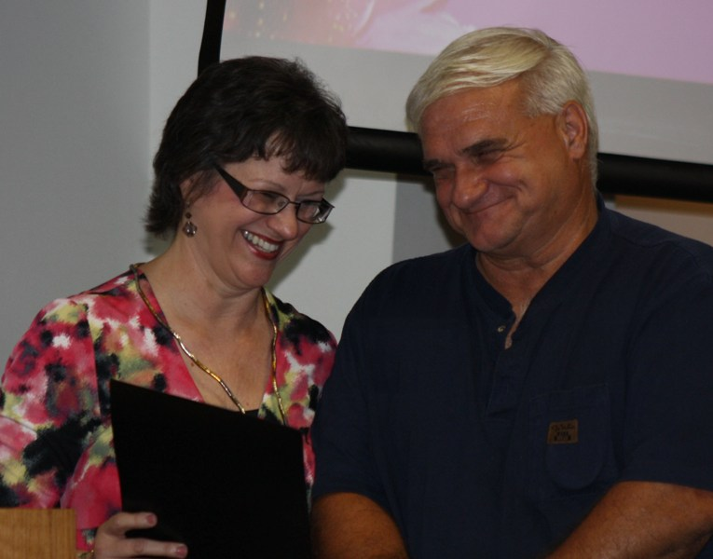
Elder Caregiver of the Year - Pictured is, left, Pamela K. Matura, Executive Director of the Area Agency on Aging District 7, Inc., who presents a certificate to Scioto County resident George Gray, who was recently recognized by the Ohio Department of Aging as an Elder Caregiver of the Year.

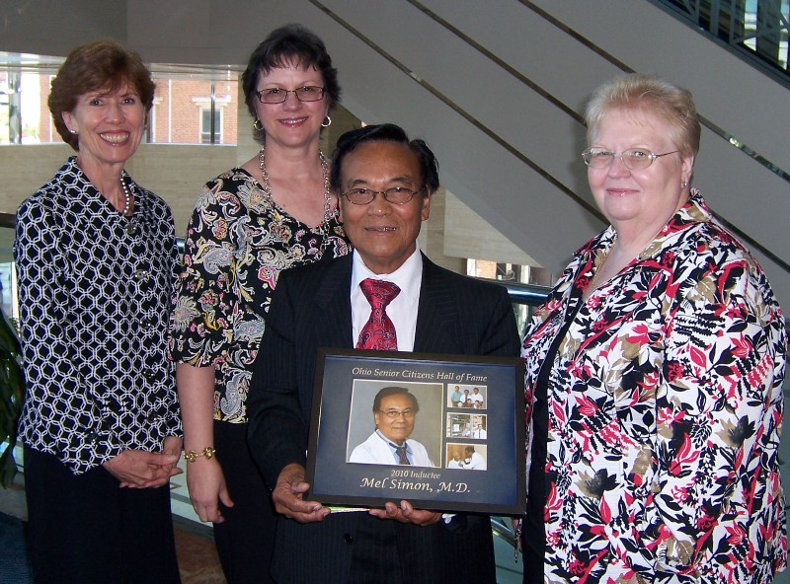
Senior Hall of Fame Inductee - Pictured at the Ohio Department of Aging’s Senior Hall of Fame Induction held in Columbus in May is, left to right, Barbara Riley, Director of the Ohio Department of Aging; Pamela K. Matura, Executive Director of the Area Agency on Aging District 7, Inc.; 2010 Senior Citizens Hall of Fame inductee from Gallia County, Mel Simon, MD; and Kay Allbright of the Area Agency on Aging District 7.

