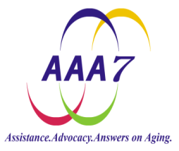
Chronic Disease Self Management/Diabetes Self Management
WorkshopLeader Application: Area Agency on Aging District 7, Inc.
F32-URG, PO Box 500, 160 Dorsey Drive, Rio Grande, Ohio 45674

Date: _______ Birthday (month & day): _______________

Name: ____________________________________________
Address: __________________________________________
__________________________________________________

Phone: __________________ E-mail: _______________

Best way to contact me: _________________________________

Emergency Contact Name: ____________________________
Phone: _________________

Gender: female male

Age group: Less than 50 yrs 50-54 yrs 55-59 yrs 60- 64 yrs 65 – 69 yrs 70 – 74 yrs
75 – 79 yrs 80 – 85 yrs Over 85 yrs

Education:
Some high school High school graduate

Some college or vocational school College graduate
Some graduate school Graduate school

Occupation or life experience: ________________________________________
_________________________________________________________________

List an chronic disease you may have: ( Examples: diabetes, arthritis, asthma, heart problems) __________________________________________________________________
__________________________________________________________________
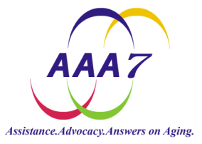
Phone: 1-800-582-7277 Fax: 1-740-245-0029

Workshop Leader Application Page 2

Other volunteer experiences: ___________________________________________

Do you speak more than one language? Yes No
If yes, what language(s): ____________________

Do you have transportation? Yes No

How did you hear about the Chronic Disease/Diabetes Classes?
Flyer Newspaper Word of mouth Presentation
Other_________________________________________

Why are you interested in becoming a workshop leader? ______________________________________________________
______________________________________________________
My Basic Availability:
I would be available for sessions held:
Monday + Wednesday Tuesday + Thursday
Wednesday + Friday

Best time of day: (2 hour sessions)
Mornings Afternoons
- Not sure- please call me when you are scheduling a class

- The best location for me is:

- Adams County Brown County Gallia County
- Highland County Jackson County Lawrence County
- Pike County Ross County Scioto County
- Vinton County

Additional Comments:

